# GIC Track Dashboard User Manual

## Software and Libraries Required for the Dashboard

### Python

1. Download Python from <https://www.python.org/ftp/python/3.10.5/python-3.10.5-amd64.exe>.
2. Run the Python installer file. Make sure to tick the “Add Python 3.10 to PATH” as shown in Figure 1 before selecting “Install Now”. Graphical user interface, text, application

   Description automatically generated

Figure 1 - Python Installer Interface

1. Once finished, Windows user can run the “Requirements.bat” attached to install the required Python libraries.  
   For Mac users, all the libraries required can be installed with “pip install -r Requirements.bat” on the Terminal.

### MATLAB

1. The dashboard is tested with MATLAB R2022b but should work on any future versions as well.
2. “Curve Fitting Toolbox” and “Parallel Computing Toolbox” Add-on in MATLAB is also required to run the dashboard.

## Downloading and Running the Dashboard

1. The dashboard could be downloaded from <https://github.com/GenomeImagingCentre/GIC-Track> as shown below. A screenshot of a computer

   Description automatically generated
2. After downloading, unzip and run the GIC.py file directly.

## Data Uploading

1. The dashboard takes in 2 types of data, microscope images in .tif format or trajectories data in .mat format.
   1. ImageJ can be downloaded at <https://imagej.nih.gov/ij/download.html>.
   2. A folder known as “Fiji Scripts” in the directory of the dashboard contains macro that convert .nd2 file format to .tif format for the dashboard.
      1. To use the Fiji Script, first run the ImageJ program, then File > Open… and select the ND2_To_Tiff.ijm.
      2. On the new pop-up window, select Run > Run.
      3. Select the folder with .nd2 files (make sure the folder contains no other files), then select another folder (can’t be the same folder) for the newly converted .tif files.
      4. Wait for the ImageJ to finish converting all the files.
   3. If another localization and tracking algorithm is preferred, the trajectories file created by other software/program can be uploaded to the dashboard by using the “Upload Post-Processed Files” in the “Upload” tab in the dashboard.
      1. The .mat file must contain a “struct” named “trackedPar” with “Fields” named “xy”, “Frame” and “TimeStamp”.
      2. Each row in the field is a trajectory data, so the information in “xy” should be in [x1 y1; x2 y2; …] (µm), with “Frame” information in [f1; f2; …] (integer) and “TimeStamp” in [t1; t2; …] (in milliseconds).
      3. A MATLAB script known as “trackmateToTrackedPar.m” is in “Fiji Scripts” folder in the dashboard directory that could help convert ThunderSTORM (<https://zitmen.github.io/thunderstorm/>) trajectory to the format that will be accepted by the dashboard.
         1. The user will need to edit line 2 of the “trackmateToTrackedPar.m” file to where their Fiji’s scripts directory is.
         2. Upon running the script after editing the line 2, the user have to select the folder contains the .xml output of the ThunderSTORM.
         3. A new folder known as “Data” will be created in the folder containing the .xml files where all the .mat files that are ready to be uploaded to the dashboard.
2. If the user decides to upload microscope images in .tif format, the user will have to define the parameters in the “Upload” tab. The key parameters are highlighted in red boxes labelled A, B and C.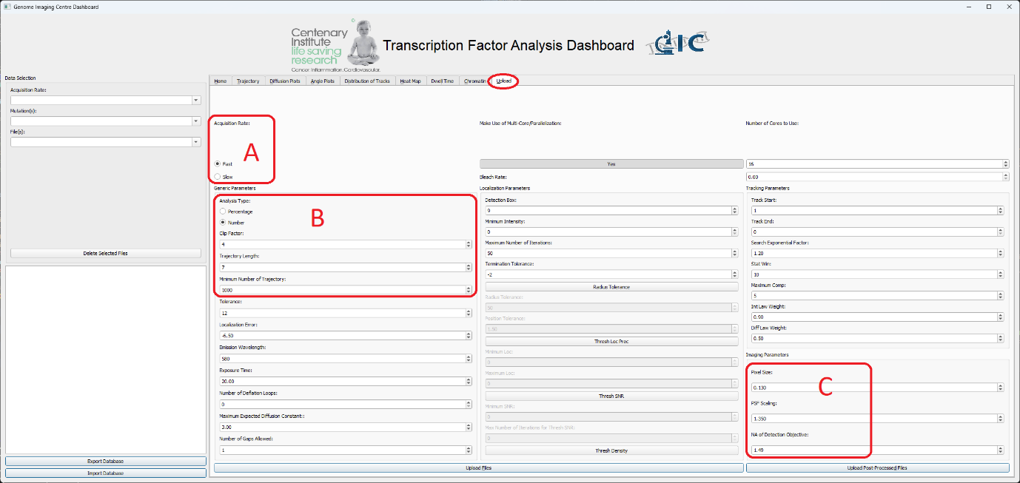
   1. Box A allows the user to define the uploaded data are “Fast” or “Slow” data, dwell time will only be computed on the “Slow” data.
   2. Box B consists of Quality Control (QC), “Analysis Type” decides whether a percentage of each trajectory to be used for the mean square displacement (MSD) based diffusion coefficient analysis or a fixed number of frames to be used, “Clip Factor” defines the number (either a percentage or number of frames based on “Analysis Type” chosen) to be used for the MSD-based analysis, “Trajectory Length” defines the minimum number of frames each trajectory must have (any trajectory that exist less than this number of frames will be discarded, this is used to ensure short-lived trajectories doesn’t artificially shift the dataset [this is mostly used in “Fast” analysis]) and “Minimum Number of Trajectory” is the minimum number of trajectories each uploaded file must have to be accepted (the file will not be processed if it doesn’t have this number of trajectories).
   3. Box C consists of the imaging parameters that are used to capture the image (from microscope).